**Collision Theory vs. Transition Theory**

Two conceptual models to model kinetics of reactions

**The rate equation**

-rA = -1/V * dNA/dt = amount A disappearing / (volume * time) = [mol/ (m3 * s)]

aA + bB --> cC + dD

rA/-a = rB/-b = rC/c = rD/d

-rA = kCACB (elementary reaction: A + B --> C)

**Non-elementary reactions**

H2 + Br2 --> 2HBr

rHBr = (k1[H2][Br2]1/2)/(k2 + [HBr]/[Br2])

Start with known elementary reactions and guess and see what works

Steady-state systems in equilibrium

-rA = kCAaCBbCCc...

a + b + c + ... = n (reaction order)

Dimensions of rate constant = time-1 concentration1-n

**Example**

B + 2D --> 3T

-rB = kBCBCD2

-rD = kDCBCD2

rT = kTCBCD2

-rB = -1/2 * rD = 1/3 * rT

kB = 1/2 * kD = 1/3 * kT

**First Order Reaction**

-ri = kCi = kCi0 (1 - X) = k(Ci0 + viξ/V)

ξ = (Ni-Ni0)/vi = V(Ci-Ci0)/vi

**Example 1: Irreversible**

2A + B --> 3C

rA = 2 rB = -2/3 rC

**Example 2: Reversible --> Two reactions**

A + B <--> C

A + B --> C

C --> A + B

rA1 = k1CACB

rA2 = k2CC

rB1 = k1CACB

rB2 = k2CC

rC1 = k1CACB

rC2 = k2CC

rA = -k1CACB + k2CC

rB = -k1CACB + k2CC

rC = k1CACB - k2CC

**Arrhenius’ Law**

Rate expression written as product of temperature-dependent term and composition-dependent term.

ri = f1(temperature) * f2(composition) = k * f2(composition)

k = k0e-E/RT

E = activation energy of reaction

T = temperature

R = gas constant

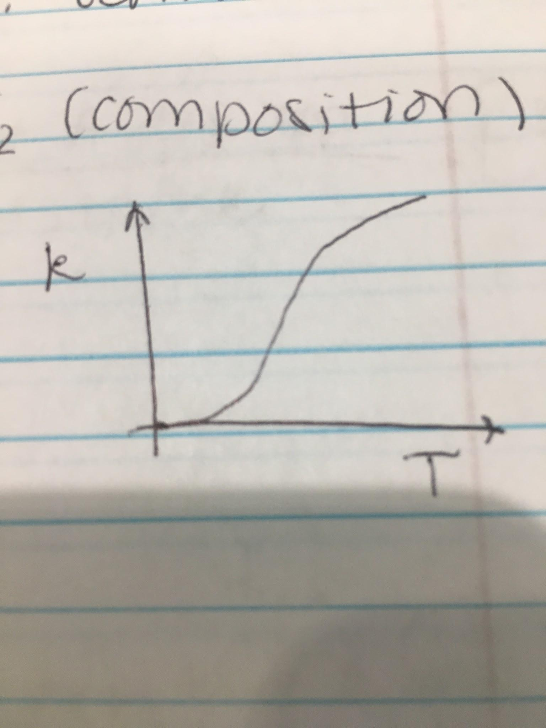

ln(k) = ln(k0) - E/RT, slope of line = -E/R

ln(r1/r2) = E/R (1/T1 - 1/T2) (provided E is constant)

* Reactions are more sensitive at lower temperatures
* Reactions with higher E are more temperature-sensitive

**Example**

63oC for 30 minutes = T1 + 273

74oC for 15 seconds = T2 + 273

r ∝ 1/t

ln(r2/r1) = ln(t1/t2) = ln(k2/k1) = E/R (T1-T2)

ln(30*60/15) = E/8.314 (1/336 - 1/347)